Explanation of Personalized item-based recommendation

Importing Necessary Libraries:
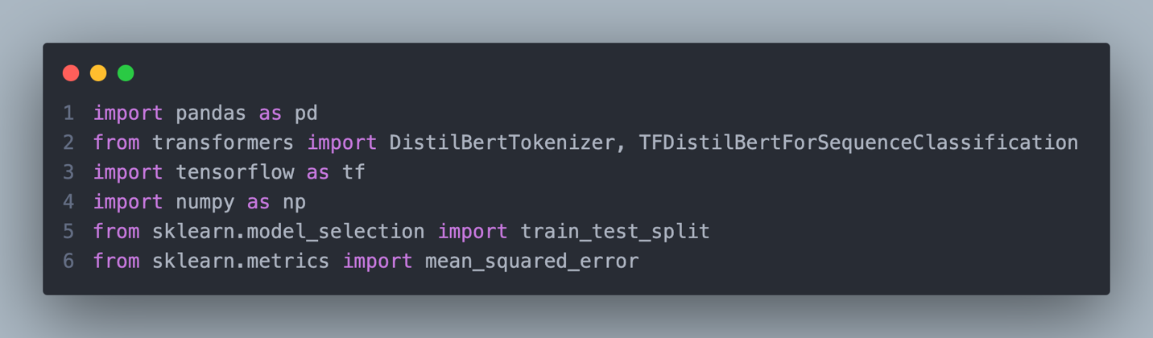
This kernel imports essential Python libraries for data processing, machine learning, and sequence classification:
- pandas: For data handling and manipulation.
- transformers: To use the pre-trained DistilBERT model for sequence classification.
- tensorflow: For building and training the deep learning model.
- numpy: For numerical computations.
- sklearn: For splitting datasets and calculating evaluation metrics like Mean Squared Error (MSE).

Loading and Merging Data:
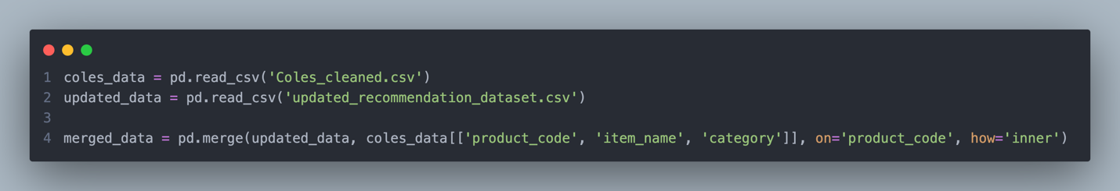
Loading Data: The Coles_cleaned.csv and updated_recommendation_dataset.csv datasets are loaded into separate DataFrames.
Merging Data: The two datasets are merged on the product_code column to combine product details with user ratings.

Identify Popular Products:
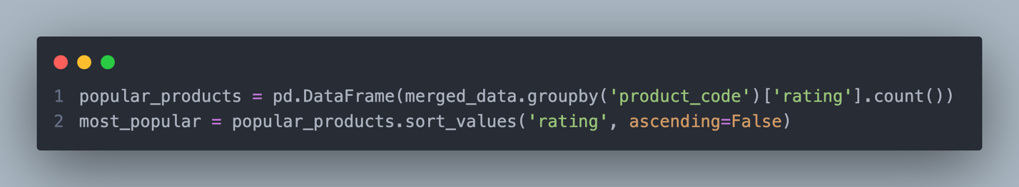
- Grouping: Groups data by product_code and counts the number of ratings for each product.
- Sorting: Sorts products by the number of ratings in descending order to identify the most popular products.

Utility Matrix Creation:
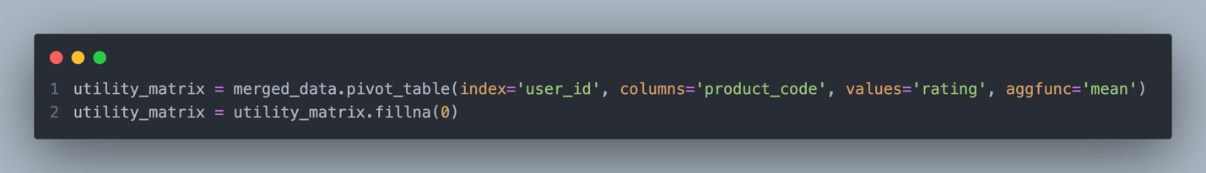
- Utility Matrix: Creates a matrix where rows represent users, columns represent products, and cell values represent ratings.
- Handling Missing Values: Fills unrated items with 0 to ensure the matrix is complete.

Tokenizing Product Names:
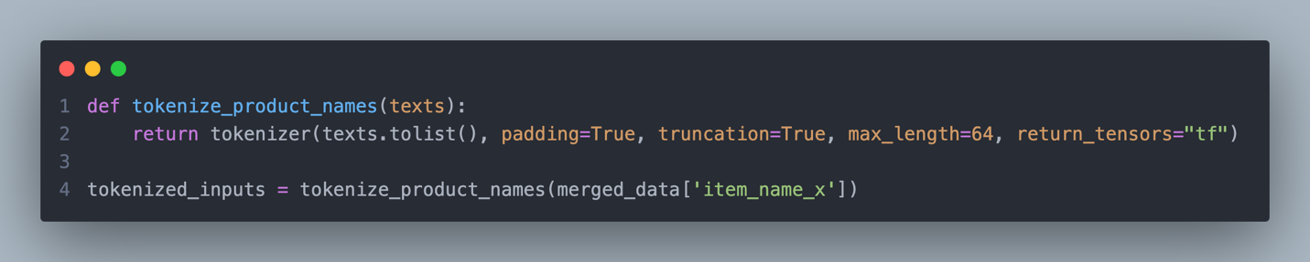
- Defines a function to tokenize product names using the DistilBERT tokenizer.
- Tokenizes the item_name_x column from the merged dataset into tensors.

Data Preparation for Model Training:
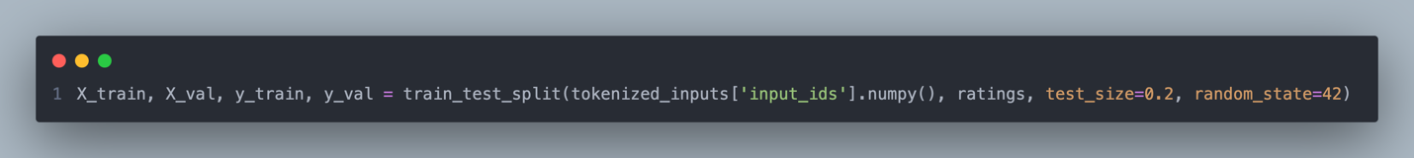
- Splits the tokenized input IDs and ratings into training and validation sets.

Creating Datasets for TensorFlow:
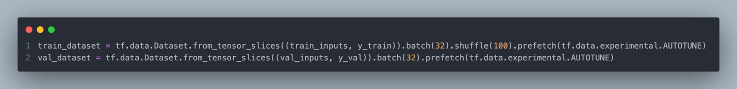
- Converts data into TensorFlow datasets for efficient model training and validation.
- Uses batching, shuffling, and prefetching to optimize performance.

Training the DistilBERT Model:
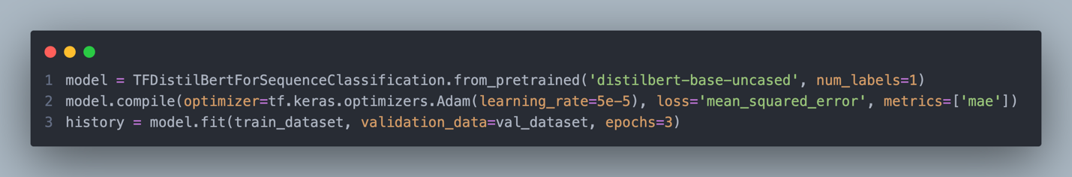
- Loads the DistilBERT model for sequence classification, configured to predict a single label (rating).
- Compiles the model with the Adam optimizer, MSE loss, and MAE as a metric.
- Trains the model on the training dataset with validation.

Generating Predictions and Evaluation:
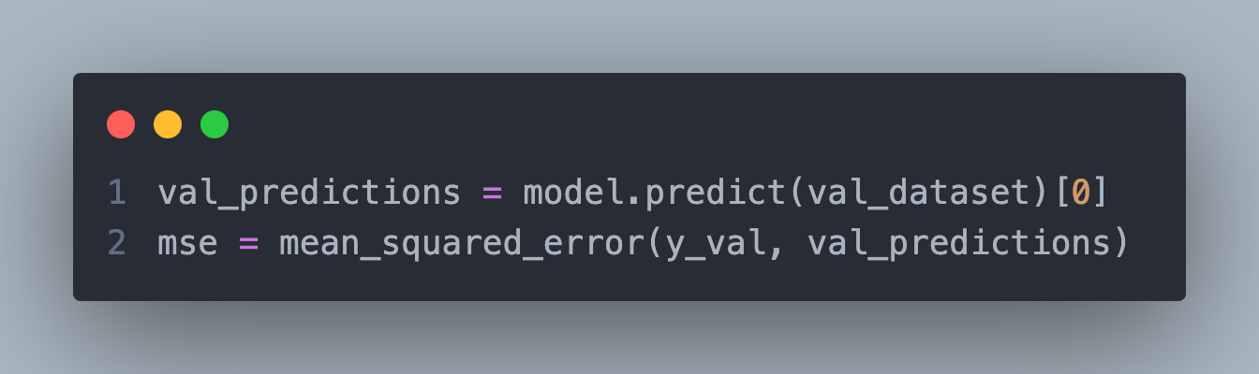
- Generates predictions for the validation set.
- Evaluates model performance using Mean Squared Error (MSE).

Predicting Ratings for all items:
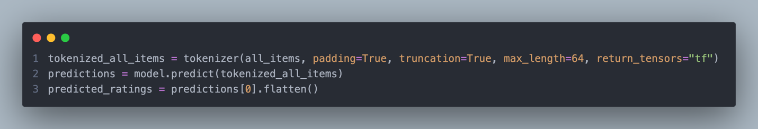
- Tokenizes all product names for prediction.
- Predicts ratings for all products using the trained model.
- Flattens the predicted ratings for consistency.

Creating a DataFrame for Predictions:
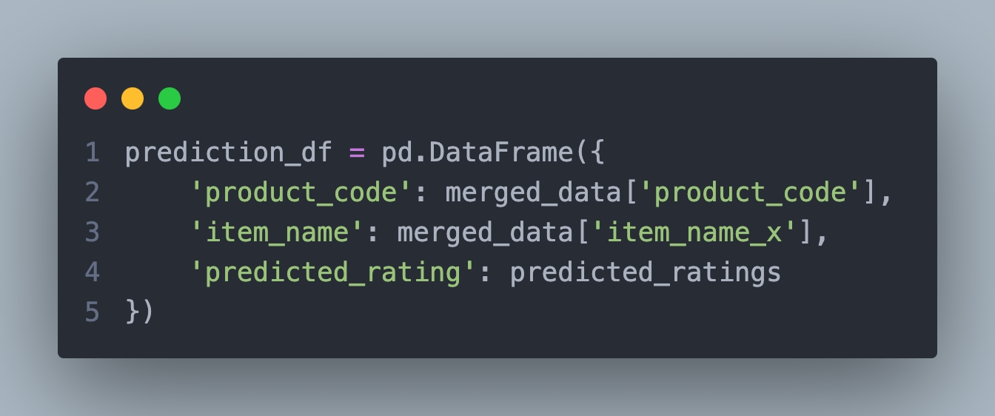
- Creates a DataFrame containing product details and their predicted ratings.

Recommendation Function:
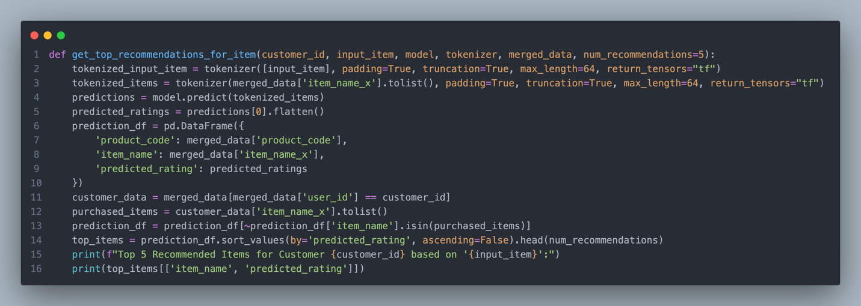
- Predicts ratings for all products.
- Filters out products already purchased by the customer.
- Recommends the top-rated products for the customer based on the predicted ratings.

Example Usage:
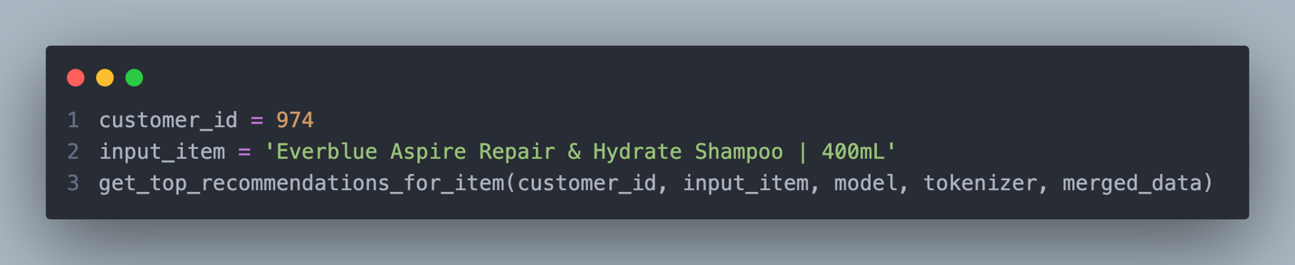
- Generates personalized recommendations for a customer based on an input product.
This approach ensures an efficient and tailored recommendation system using a combination of NLP and deep learning.

